Atlassian Case Study Answers and Discussion
- If you were T. Rowe Price, would you invest $150 million USD in Atlassian at a valuation of $3.3 billion USD? Why or why not?
If we were T. Rowe Price, we would NOT do this deal because it is exceptionally unlikely that we’ll be able to realize our targeted 20% IRR.
While Atlassian is a great company, the $3.3 billion valuation, along with its expected growth rates and margins, make a 20% IRR over a 3-5 year holding period implausible.
The company’s valuation at the time of the T. Rowe Price investment – approximately 110x EBITDA – was already exceptionally high.
To achieve a 20% IRR, however, the company’s value would need to climb even higher – to the 130-140x range in our “Base Case” scenario – if there is no liquidity event for another 3-4 years:
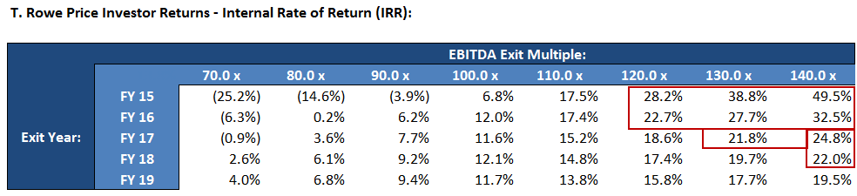
While this is possible, generally the multiples decline over time as the company grows.
Here, Atlassian grows from $200 million in revenue (34% historical growth) in FY14 to $459 million (12% trailing growth) in FY19.
It is extremely unlikely that a $459 million company growing at 12% per year will be valued at a higher multiple than a $200 million company growing at 34% per year.
In our Base Case scenario, the customer count grows from 35,000 to 70,000 over 5-years (15% CAGR), while the average selling price increases by 3% per year for 5 years. We assume that the operating margin falls from 10.6% to 8.6% over 5 years, primarily because of added sales & marketing spending.
Even with more optimistic assumptions, however, it is highly unlikely that T. Rowe Price will realize a 20% IRR.
For example, if the customer count increased to 100,000 rather than 70,000, implying Year 5 revenue of $645 million, the baseline IRR would only increase marginally, from 13.8% to 15.0%:
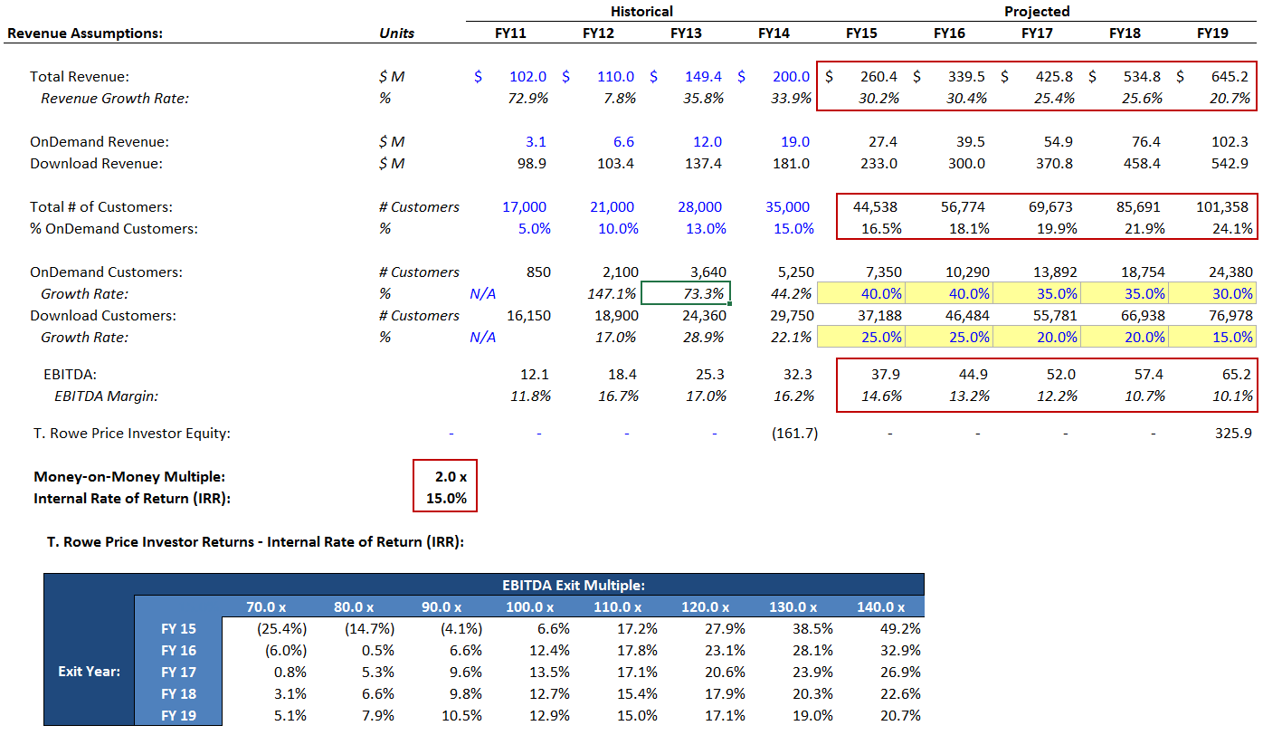
This happens because the average sales & marketing expense per new customer increases from approximately $2,000 in FY14 to $4,000 in FY19 (in the 5 years prior to that, it increased from $1,500 to $2,000).
This large increase reflects our view that it will become more and more expensive to win customer accounts at bigger companies with higher user counts.
If the average sales & marketing expense per new customer only increased to $3,000 over 5 years, we would achieve exactly a 20% IRR over the 5-year holding period, still assuming 100,000 customers and the same exit multiple:
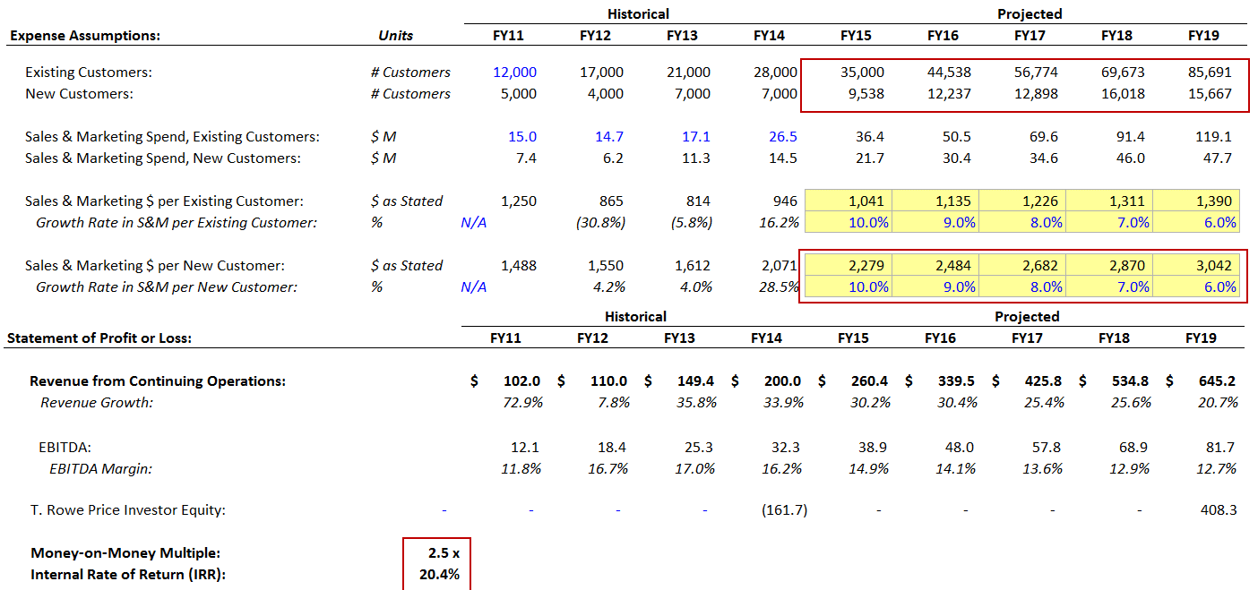
But there is still a problem even under these optimistic assumptions: the exit multiple must stay the same for T. Rowe Price to realize a 20% IRR:
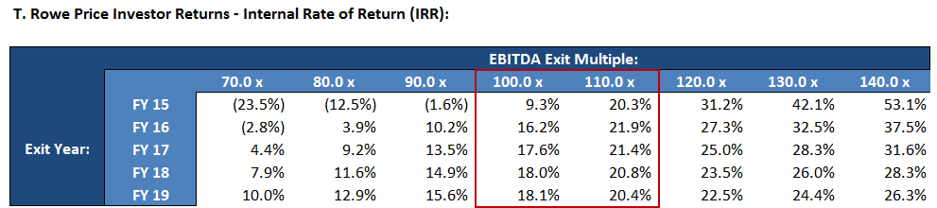
If the multiple drops by even ~10%, the IRRs fall to below 20%; and if it drops by more than that, the IRRs fall even more substantially.
So to achieve a 20% IRR:
- The company’s customer base has to triple;
- Its average sales & marketing expense per new customer also has to increase by 50% less than expected; and
- The exit multiple has to remain the same – even though Atlassian’s growth rate and margins are both lower by Year 5.
It is extremely unlikely that all of these will happen, but it is possible that one or two of them may transpire over the next 5 years.
While Atlassian is a great company, we see it as a 10-15% IRR investment as opposed to one in the 20%+ range, based on the different scenarios we have analyzed.
As a result, we recommend AGAINST investing $150 million in the company at a valuation of $3.3 billion.

- If your answer is “no,” what conditions would have to be true for you to change your decision and invest in the company anyway? For example, if the company’s growth rates, margins, or its valuation were different, would your decision change?

If your answer is “yes,” what investment terms might you stipulate to protect yourself in this deal?
The greatest uncertainty here surrounds Atlassian’s margins and sales & marketing spending in the future.
As shown above, the customer count and revenue growth rate make far less of a difference than the margins do.
Even if the customer count increased to 140,000 over 5 years – a 4x increase – the IRR would still not reach 20% under our baseline assumptions!
We also view an increase from 35,000 to 140,000 customers over 5 years as completely implausible, given that the customer base only increased from 17,000 to 35,000 over the past 4 years.
Therefore, a “condition” on the customer count is not particularly realistic or helpful.
Instead, we would look to the company’s sales & marketing spending and its pricing policies as better “levers” to pull.
On the margin / expense side, suppose that we used the following assumptions instead (while keeping the total customer count at 70,000 by Year 5):
- Sales & Marketing per New Customer: Increases by only 4% per year over 5 years, reaching $2,500 by the end instead of $4,000.
- Sales & Marketing per Existing Customer: Increases by only 4% per year over 5 years, reaching $1,150 by the end instead of $1,400.
- G&A Variable Expenses: It falls from 10% of revenue to 8% over 5 years, rather than increasing from 10% of revenue to 12%.
With this set of assumptions, the company’s revenue still increases to $459 million after 5 years, but now the EBITDA margin increases from 16% to 22% in that same period:

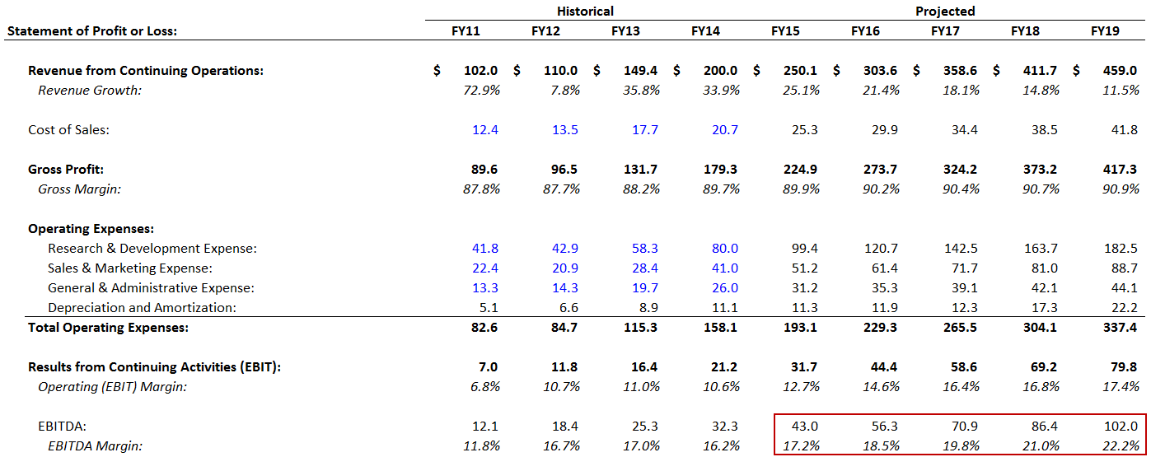
And the IRR also increases so much that even with a ~20% drop in valuation, a 5-year 20% IRR is still plausible:
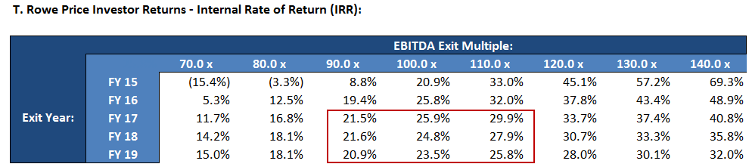
Of course, there are other ways to get to the same outcome.
For example, the company could gradually scale down its R&D spending from 40% of revenue to 30% of revenue over the 5-year period, and achieve a final year EBITDA margin of 23%:
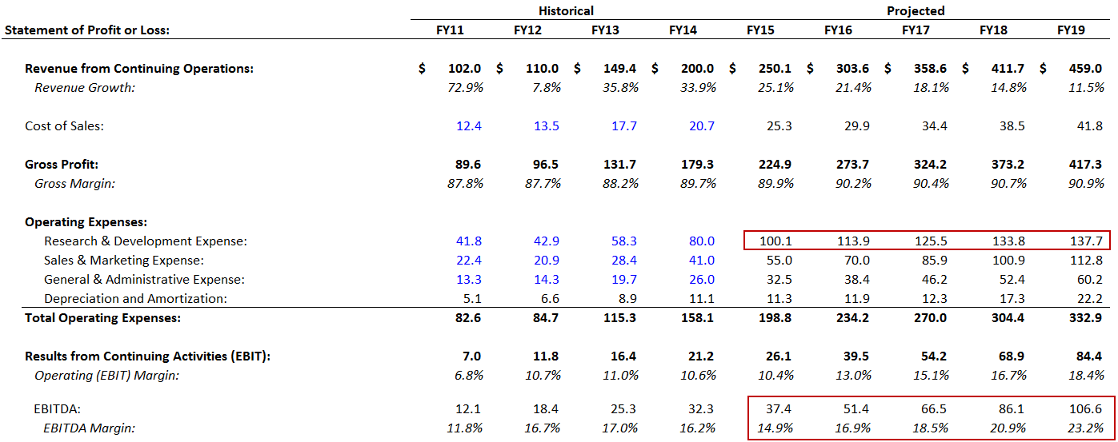
It is unclear if this substantial cut in R&D spending will impact the company’s sales growth at all.
Thirty percent of revenue spent on R&D is still quite significant, but we would need more detail on the deployment of technical and engineering employees before we could determine if this reduction is feasible.
Finally, it is also worth asking if Atlassian has room to increase its product pricing, rather than reducing its pricing as it has done in prior years.
Our baseline scenario assumes only a 3% increase in average customer value per year, reflecting modest price increases to keep pace with inflation.
But if the average customer value increased by 5% per year instead, the 5-year IRR would increase to 20% as well.
Although the company’s revenue does not increase by a huge amount (in the final year it’s $505 million rather than $459 million), its EBITDA margin stays at ~16% instead of declining to ~14%, which makes a big difference in the final numbers:
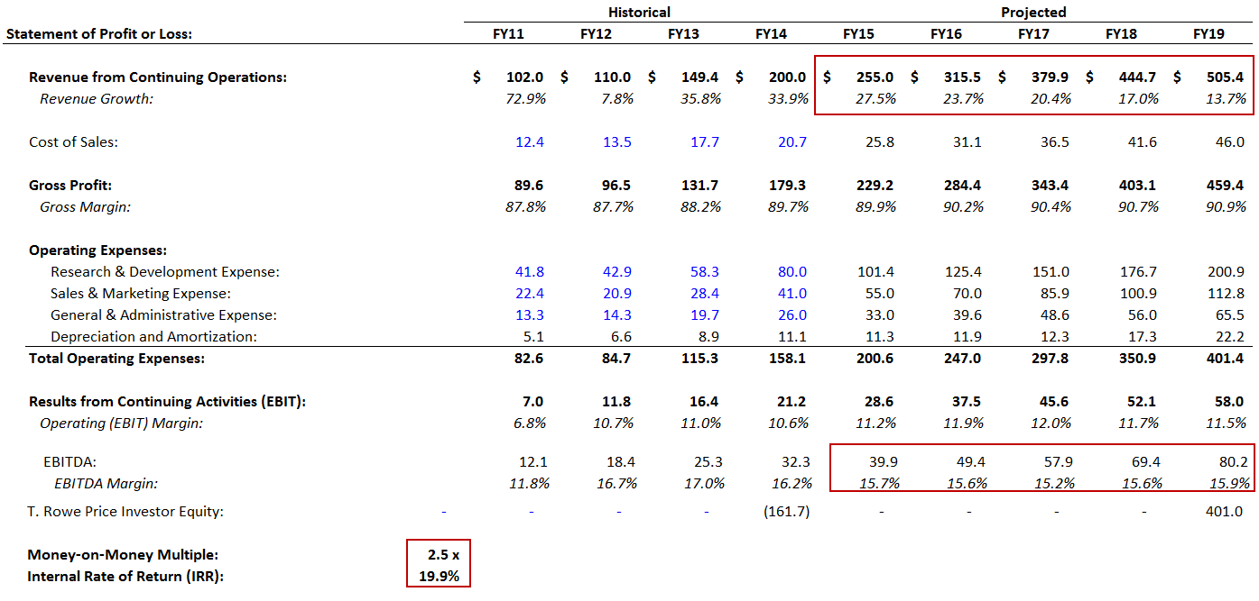
And there may be room to increase prices by even more than 5% per year – even if customer growth slows as a result of these price increases, the trade-off could easily be worth it, especially if new customer acquisition costs increase as we have predicted.
In summary, the following conditions would have to be true for us to feel comfortable investing $150 million in Atlassian at a valuation of $3.3 billion:
- The EBITDA Margin would have to increase from 16% to at least 20% over the 5-year projection period, via some combination of lower-than-expected increases in customer acquisition costs, reduced R&D spending, and/or reduced G&A spending; and

- Average customer value would have to increase by at least 4-5% per year rather than 3% per year over the 5-year projection period in this case study.

- At an Atlassian valuation of $3.3 billion, Accel’s 15% stake is worth $495 million, so it was not possible for them to sell the entire stake to T. Rowe Price. However, press releases and news reports confirm that Accel did sell at least some of its stake, “taking money off the table.”

Do you agree with this decision? How much do you think Accel should have sold, and why? Or if you disagree with the decision, why would Accel be better off waiting to sell?
Since Accel is targeting a 10% money-on-money (MoM) multiple with its investment, we need to look at the multiple under different scenarios to answer this question.
In our baseline scenario, with revenue growing to $459 million and final year EBITDA of $61.8 million (14% margin), Accel seems likely to realize a multiple well above 10x if Atlassian’s valuation stays the same or increases over the next 5 years:
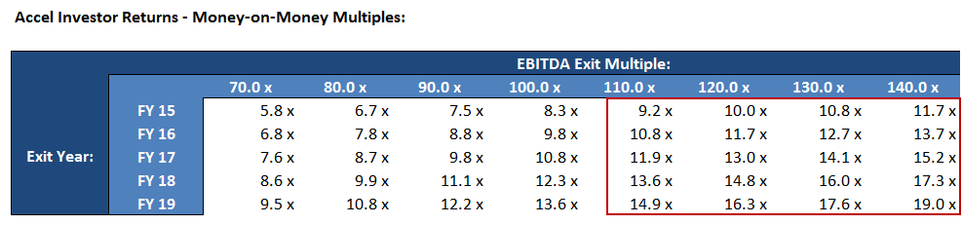
Even if Atlassian’s valuation falls by over 40%, Accel will still realize a 10x multiple on its investment if it waits until FY19 to sell its stake.
So on the surface, the firm’s decision to sell part of its stake does not make much sense:
- AT MOST, Accel could sell $150 million of its stake to T. Rowe Price, leaving it with a stake worth $345 million, or 10.5% of the company.

- $150 million represents a 2.5x return on Accel’s initial investment of $60 million, which is a long ways away from its stated goal of a 10x return.

- In some sense, this reduces the investment risk because now Accel has taken money off the table and recovered 2.5x of its initial investment. So even if Atlassian collapses or otherwise turns into a disaster, Accel cannot possibly lose money on this deal.

- But with a company like Atlassian it is exceptionally unlikely that returns would ever turn negative – because it is still growing quickly and actually commanded a higher multiple 4 years after Accel’s initial investment.

- And owning LESS of a company only limits investment losses in extreme downside scenarios where the returns turn negative.
To illustrate these points, let’s take a look at what happens if we assume that the entire $150 million investment from T. Rowe Price goes to Accel cashing out part of its existing stake:
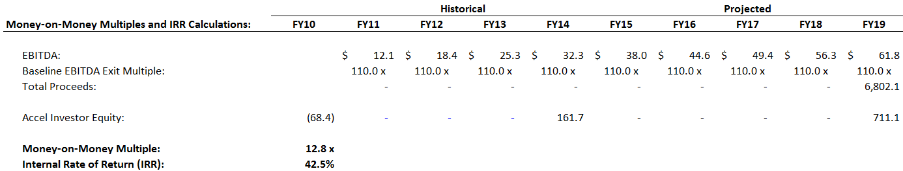
While the IRR increases in this scenario, the money-on-money multiple actually decreases since Accel owns 4.5% less of the company by the end of the 5-year projection period:
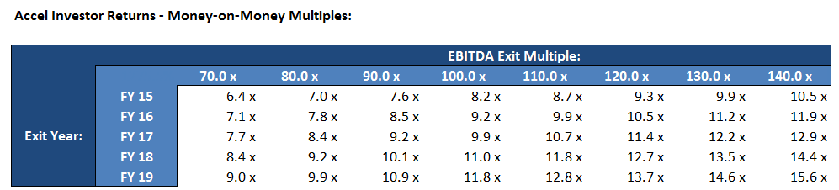
Of course, Accel did not actually sell $150 million of its stake to T. Rowe Price since most of the shares came from employees selling their stock.
So if Accel sold only $20 million or $50 million, its potential money-on-money multiples would not decrease by as much as what was shown here – but they would still decline.
This move to sell shares would make more sense for a later-stage investor that really IS looking to take money off the table and is aiming for only a 2-3x return on investment.
In short, Accel’s move to sell some of its stake does not make much sense because it actually hurts its chances to realize a 10x return on its initial investment.
This move would only make sense if:
- Accel has detailed knowledge that the company’s future financial performance will be significantly worse than what we have projected here (thereby reducing final year EBITDA and the likely EBITDA exit multiple).

- It is actually targeting a specific IRR rather than a money-on-money multiple.
- Accel knows or believes that Atlassian will not sell or go public for a very long time (more than 5 years in the future), and it wants to realize some of its returns earlier than that.

- If you were to pursue this investment opportunity, what areas would you need to perform further due diligence on? For example, are there any assumptions critical to your view of the company that you had less conviction on? What are the top 2-3 most important figures and assumptions that you need to research in more detail?
As mentioned above, the key drivers in this deal are the company’s planned sales & marketing spending, R&D spending, and pricing increases.
To a lesser extent, its customer growth expectations and total potential customer base also make a difference, and we would need to perform further due diligence on those to feel 100% comfortable with this deal.
The top 2-3 most important figures and assumptions we need to research in more detail are as follows:
- Customer Acquisition Costs: What is the historical trend for Sales & Marketing Spending per New Customer and Sales & Marketing Spending per Existing Customer, and how does the company expect both these numbers to change in the future? This is critical because new customers may actually reduce the company’s margins if customer acquisition costs grow too high.

- Plans for R&D Spending: Atlassian’s business model allows it to spend significantly more on research & development than peer companies, but this is both a strength and a weakness since 40% of sales spent on R&D is quite high. What are the company’s future plans, and how important are these activities to revenue growth? Even a modest reduction in R&D spending from 40% to 35% of revenue could make a huge impact on the returns.

- Average Customer Value / Plans for Product Pricing: Historically, the company has reduced pricing on many of its products. This may not have been the best decision, because its average customer value has not changed much over the past 4 years while its per-customer sales & marketing expenses have increased

If there is room to increase average customer value by more than 3% per year, that could also significantly increase the IRR; but if there is substantial downward pricing pressure, that might force the company’s margins down and further reduce IRR.

Other interesting, but less important, areas include:
- Total Addressable Market and Relationship to Sales & Marketing: We assume in the baseline scenario that Atlassian increases its customer count to 70,000 at the end of 5 years – but is that plausible?

Atlassian’s pricing for the OnDemand version of JIRA, as of the time of this case study, was $500 / month for 500 users and $300 / month for 100 users. The Download version pricing was $4,000 for 100 users and $8,000 for 500 users.

Since Atlassian’s average customer value is close to $6,000, this implies that its average customer has close to 500 users.

But Atlassian sells tools primarily for software developers and engineering organizations – which brings up the question of how many companies worldwide have hundreds of employees in that function. There may not actually be 100,000, or even 70,000, potential customers in this market.

It would also be interesting to know how much additional sales & marketing spending is required to reach these new customers, and whether or not the company will need commissioned sales reps to grow past a certain point.

- OnDemand vs. Download Customer Split: In our Base Case scenario, we have not assumed a massive shift to the OnDemand segment – about 15% of customers are OnDemand in FY14 vs. 19% in FY19.

However, this could easily be wrong – and that would have implications for the average customer value, customer acquisition costs, and more.

In particular, it would be interesting to know the sales & marketing spending per OnDemand customer vs. Download customer, and see how that compares to the sales & marketing spending per existing customer vs. new customer.

- G&A Spending: While this is less significant than sales & marketing, it does still comprise around 13% of revenue in Atlassian’s most recent fiscal year, and it’s an area ripe for potential cost savings.

Cutting sales & marketing spending may not even be possible, and cutting R&D spending might have negative long-term consequences, but general & administrative costs can often be reduced with less hassle.

- In hindsight, was it a good idea for Atlassian to reduce its prices significantly in 2011 to win more customers, and to offer the on-demand model for its products? What are the financial implications of these decisions?
It is tough to answer this question because we don’t know the “counter-factual” – how Atlassian’s customer count would have changed WITHOUT the reduced pricing.
However, we can make an educated guess about the financial and operational impact of these decisions:
- FY09: 10,000 customers; revenue of $44 million; average customer value of $4,426.
- FY10: 12,000 customers; revenue of $59 million; average customer value of $4,917.
- FY11: 17,000 customers; revenue of $102 million; average customer value of $6,000.
- FY12: 21,000 customers; revenue of $110 million; average customer value of $5,238.
For reference, Atlassian changed its JIRA pricing from $150 / month for 10 users to $10 / month for 10 users in FY11.
Technically, it seems like this reduced pricing greatly reduced the average customer value.
But the FY11 value was already a substantial increase over the average customer value in the two prior years, so it may not mean that much.
On the other hand, it also doesn’t seem like this pricing change greatly increased Atlassian’s customer count.
By reducing the per-user prices, Atlassian shifted its business model and must now focus on acquiring more users from existing customers to make up the difference.
Given that it is significantly more expensive to win new customers than to market to existing ones, this may have been a wise decision if Atlassian is confident it can boost the user count at existing accounts.
However, it also means that the company must focus more on large accounts with a high number of potential users – if customer acquisition costs are currently ~$2,000, it no longer makes sense to pursue companies with only 10 potential users.
Bottom-Line: We would probably rate this a “neutral” impact in the absence of further information.
The switch to on-demand is even harder to assess because we need more information on the average number of years customers stay subscribed, the churn rate (the percentage that cancel each year), and the “breakeven point” at which new customers become profitable.
Broadly speaking, switching to subscription-based business models hurts accounting profits (Net Income) in the short-term because revenue must be recognized over a long time period, but many costs such as commissions are paid upfront… but in the long-term, it can actually boost cash flow due to the high amount of deferred revenue being generated.
We expect a more positive impact on Atlassian because the company does not have commissioned sales reps, which eliminates one of the biggest upfront costs – so the profit impact is likely “neutral,” with a positive long-term cash flow impact.

- Do you think the growth numbers and margins you have projected are achievable? What is the relationship between average customer value, growth, and the total number of customers the company can potentially sell to?
Yes, the growth and margin numbers here seem achievable because revenue growth rates decline each year and are well below historical levels, the total customer count by the end of the period does not seem outrageous, and the margins actually decrease by 2-3% due to additional S&M and G&A spending.
- Revenue: Historically, revenue doubled between FY11 and FY14, growing from $102 million to $200 million; here, it also doubles over 4 years, growing from $200 million in FY14 to $412 million in FY18.

- Revenue Growth Rates: These decline over time, starting at 25% in FY15 and then falling to 12% by FY19.

- Source of Growth: Most revenue growth comes from winning additional customers, as opposed to pricing increases, with the count growing from 35,000 to 70,000+ by FY19. In the 4 years prior to this, the customer base increased from 17,000 to 35,000.

- Margins: Historically, the company’s Operating Margin was in the 7-11% range; here, it starts at 11% and falls to 9% by the end. The EBITDA margin was 12-17% historically, and here it falls from 16% to 14% by the end.

- Expenses: Some expenses, such as G&A, actually increase as percentages of revenue; for others, such as sales & marketing, we increase the per-customer expense substantially over time in order to be as conservative as possible.
There is a question over the total addressable market, and whether or not the company can really serve 70,000+ customers eventually.
We believe that to reach that level, Atlassian will have to spend significantly more on sales & marketing since many of these customers are larger accounts that require more time and effort to sell to.

- How do Atlassian’s business and business model compare to other “hot” tech companies at this point in time, such as Box, Dropbox, and Square? What is more appealing and what is less appealing vis-à-vis peer companies? What about compared to companies in similar markets, such as 37 Signals / Basecamp, Wrike, and Github?
Atlassian is far more profitable and cash flow-positive than companies such as Box, Dropbox, and Square, most of which are losing enormous sums of money.
That alone makes it a more appealing business, but there are several other factors to consider.
For one, Atlassian sells to very different users and customers than these other companies – it is focused on developers and more technical employees, while the others offer more “general purpose” tools and software for businesses at large.
The companies mentioned in the second set above – Basecamp, Wrike, and Github – are much smaller and/or newer, so we focus on Box, Dropbox, and Square in the comparison below:
- Growth and Growth Potential: Box, Dropbox, and Square have grown at faster rates than Atlassian in recent years, and may have higher future growth potential.

According to its S-1 filing, for example, Box grew from $59 million in revenue to $124 million in revenue in its most recent fiscal year as of the time of this case study, representing 110% growth, compared to Atlassian’s 34% growth.

Dropbox, meanwhile, grew sales from $46 million in 2011 to $116 million in 2012 (152% growth) to approximately $200 million in 2013 (72% growth).

As of the time of this case study, Square had disclosed less information about its financials, but its net revenue was approximately $130-140 million in 2013, with revenue expected to double in 2014 ($260-280 million), also representing significantly higher growth than Atlassian.

Furthermore, these 3 companies all serve broader markets (online file storage/sharing and payment processing) than Atlassian, so it is likely they will continue to grow more quickly in the future.

- Profits and Cash Flow: Here, Atlassian comes out ahead: it has been profitable and cash flow-positive since inception, with a Net Income Margin of 7% in FY14, an EBITDA margin of 16%, and an FCF margin of 15%.

By contrast, most other peer companies were losing massive amounts of money: Box, for example, lost $158 million in its most recent fiscal year and spent 138% of its revenue on sales & marketing (vs. ~21% for Atlassian).

Square’s numbers are undisclosed, but sources indicate that the company lost $100 million in 2013 (on revenue of $130-140 million).

Dropbox has allegedly been profitable, but it is unclear what its margins and whether or not it is cash flow-positive in addition to being profitable.

If it really is profitable, it is likely because it is spending less on sales & marketing as a percentage of revenue than other software companies and still has relatively high gross margins.

- Threat of New Entrants: These markets are all highly competitive, with new entrants both large and small emerging quite frequently.

In online file storage, for example, huge companies such as Apple, Microsoft, Google, and Amazon have been introducing their own products and services since they do not require huge upfront R&D investments (compared to something like Google’s search algorithm, online file storage is a relatively simple technical problem).

The payment processing space (Square), similarly, has many competitors both large (Paypal) and small (other startups) because there isn’t much loyalty to particular vendors and it’s also not an extremely difficult technical problem.

In some ways, Atlassian is similar to these other markets: the technology itself is not that complex because source code control and collaboration tools have been around for decades.

The difference is that there are not quite as many large companies attempting to enter the market, likely because it’s much smaller and more fragmented.

- Threat of Substitute Products/Services: There is a high threat of substitute products/services for almost all these companies, because there’s little to “force” customers to stick with their existing solutions.

For example, a large company that signed up for file storage via Dropbox or Box could easily switch to a competitive service offered by Microsoft or Google – all they have to do is copy and paste their files into a new service and wait for the upload to complete.

The same applies to payment processing (Square), but there it is even worse because small businesses and “micro-merchants” do not care much about payment processing and tend to use whichever solution is easiest and cheapest.

As a result, many of these companies have been attempting to move up-market and offer other business software that is “stickier.”

The same is true of Atlassian: there are so many source code control and project management / collaboration tools that very little prevents customers from switching to solutions offered by companies like 37 Signals / Basecamp, Wrike, or Github.

Github probably has the lowest threat of substitute products/services because of the social component: it is actually more of a social network for developers than a true enterprise software company.

Since users can view other users’ contributions and review source code from many different companies and individuals, over time more and more users are likely to use Github and stick with it since everyone else is using it as well.

- Bargaining Power of Customers (Buyers): In most of these markets, there is substantial downward pricing pressure – in online file storage, for example, Google shook up the industry around the time of this case study by dramatically reducing its Google Drive prices (10 TB used to be $800 / month, but they reduced prices to $100 / month).

Since there are so many substitutes for the products/services offered by these companies, and since the solutions themselves are not highly differentiated, customers have a great deal of bargaining power.

This is also true of Atlassian, as seen with its move to dramatically reduce prices several years ago; it isn’t exactly in a “price war” with Github because the two companies price their services differently (# of repositories vs. # of users), but it is unclear how much of a premium Atlassian can actually charge.

The company could gain additional bargaining power if its software were more technically complex, if there were more of a lock-in effect, or if it offered even more specialized solutions (e.g., different versions of its tools for different industries).

- Bargaining Power of Suppliers: This point is less relevant for software and Internet companies because there are no suppliers in the traditional sense, but it is worth looking at labor costs since the employees are arguably the “suppliers” here.

Companies like Box, Dropbox, and Square compete with each other for the top engineers and sales people, and often pay high base salaries even to entry-level employees (e.g., $100K+ for engineers just out of undergraduate). They have little “bargaining power” because engineers could easily leave and move to other startups or large tech companies offering the same, or higher, salaries.

Atlassian faces some of the same issues, but since it is based in Australia it arguably has more power over employee wages: there are not as many tech companies or promising employers for talented engineers and sales people there, so there may be less upward pressure on wages. As the company expands overseas, however, this advantage may diminish over time.

- Intensity of Competitive Rivalry: As mentioned above, these markets (online file storage, payment processing, and developer/collaboration tools) are all highly competitive, with relatively low barriers to entry, frequent new entrants, and little product differentiation.

Atlassian’s market, in particular, has dozens of competitors offering slightly different collaboration/project management/source code control tools, ranging from high-profile venture-backed companies (Asana, Github) to self-funded companies that have been in business for 15+ years (Basecamp / 37 Signals).

Online commentary reveals that there is no clear “product winner,” and that the best solution comes down to user preferences and individual requirements.

- Even under conservative assumptions, Atlassian generates a huge amount of excess cash by the end of the 5-year projection period. How do you think it should use this cash? As an investor, how might you take advantage of this excess cash balance to mitigate risk?
The best use of cash seems to be increased investment in sales & marketing, or perhaps CapEx used to fund overseas expansion into emerging markets.
It is unclear how productive additional sales & marketing spending would be – we’ve come up with our own estimates for customer acquisition costs, but does each dollar spent actually result in progress toward a new customer?
It is also unknown what impact commissioned sales reps would have – it may be that until the company starts expanding its product offerings and going after more “mainstream” users, additional sales reps may not make much of a difference.
CapEx requirements are likely to increase as more and more customers switch to the “OnDemand” versions of the company’s products, so that could be a more sensible way to spend money. Overseas expansion, especially in relatively underpenetrated emerging markets, would also constitute a good use of CapEx.
Given that Atlassian generates a large excess cash balance by the end of Year 5 in our baseline scenario, we could argue that the company should issue a dividend to equity investors (Accel and T. Rowe Price).
This would allow them to realize some of their returns earlier on; the problem, however, is that the two firms combined own less than 20% of the company.
So such a strategy may not even make much of a difference. It would be more viable as a way to mitigate risk if the company had a true “cash cow” business with much higher margins and an even higher excess cash balance, and/or if the equity investors owned a much higher percentage of the company.

