Commercial Bank Valuation Case Study: Shawbrook [SHAW] Detailed Stock Pitch
Note that this is a lengthy pitch and is not something you would recite in response to a simple interview question unless the whole interview is an extended discussion of the company.
This example is more appropriate for a formal presentation of a stock pitch or case study.
NOTES AND DISCLAIMERS:
Please do not construe this document as “investment advice.” We are NOT recommending that you invest in any of the companies discussed here.
This document is a tutorial about how to research and pitch companies that you think are interesting, and how to use what you’ve learned in this financial modeling course to support your arguments.
Table of Contents:
- Recommendation
- Company Background
- Investment Thesis
- Catalysts
- Valuation
  - Comparable Public Companies
  - Precedent Transactions
  - Dividend Discount Model (DDM)
  - Residual Income Model
  - Regression Analysis
- Investment Risks

Stock Pitch – SHORT Recommendation for Shawbrook [SHAW]
Recommendation
We recommend shorting Shawbrook [SHAW], a “challenger bank” in the UK focused on buy-to-let mortgages, because it’s overvalued by 30-50% currently and there are at least 3-4 catalysts to change its share price in the next 12 months. The market has mispriced the company because its views of the company’s markets, asset yields, and risk weightings are all mistaken.
Currently, the market views Shawbrook as one of the most promising challenger banks in the UK, and its expects the company’s Gross Loans to nearly triple over the next five years, with its commercial mortgages increasing by 4x and its loan spreads over LIBOR staying in the same range.
We believe this view is incorrect because it implies significantly higher-than-expected GDP growth, existing buy-to-let (BTL) mortgage risk weightings staying the same, and no slowdown in the mortgage market, along with limited competition from other banks.
Instead, we believe that the company’s loan interest spreads against LIBOR are likely to fall by ~1% over the next five years, and that its entire loan portfolio will increase by only 2.0x – 2.5x, with commercial mortgages increasing by only 3x. Recent regulatory and tax changes to BTL mortgages, with more changes expected in the future, along with an already slowing housing market in the UK, explain these figures.
For the company to be significantly undervalued, UK GDP growth would have to exceed 3.0% over the next five years, LIBOR would have to increase from 0.23% to 1.55%, the company’s mortgage market share would have to be ~25% higher than expected, and long-term ROTCE would have to exceed the company’s Cost of Equity by nearly 30% (14% vs. Cost of Equity at 11%).
With more plausible assumptions of 2.0% – 2.5% GDP growth over the next five years, LIBOR increasing to 1.35%, commercial mortgage market share increasing from 0.27% to 0.80% instead of 1.00%, and a long-term ROTCE of 12% (~10% above its Cost of Equity, and in-line with the more mature comparable banks), the company is overvalued by ~30%. In a Downside Case with a recession and recovery and lower figures for LIBOR, loan market share, and long-term ROTCE, the company is overvalued by ~50%.
Catalysts include risk weightings on BTL mortgages potentially increasing from 35% to 90%, a slowdown in loan growth with mortgages growing only ~3x over the next five years, and a compression of loan yields by ~1% due to increased competition. The expiration of the lockup period on Pollen Street Capital’s 45% equity stake in the company could be another catalyst.
Investment risks include risk weightings on BTL mortgages changing by less than expected, higher-than-expected mortgage market growth or market share gains, and loan interest spreads staying the same with funding costs staying the same or decreasing.
We could mitigate these risks with call options, a strict buy-stop order, and by longing other banks in the sector.
Return to Top.
Company Background
Shawbrook is a UK-based “challenger bank” that specialized in SME lending and niche markets that require a high degree of manual underwriting and customer service. The “high street” banks, such as HSBC and Barclays, have underserved these segments because of increased regulation post-GFC and a poor fit with their existing business models.
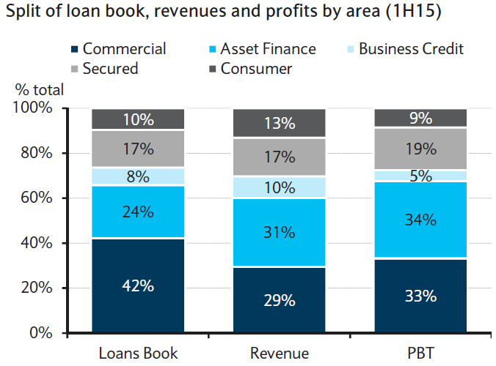
Shawbrook was founded in 2011 and has grown its loan book to £2.7 billion as of 1H15. It is split into five main segments: commercial mortgages, asset finance, secured lending, consumer lending, and business credit.
It is predominantly funded by retail deposits, which are raised online and via postal mail; the company has no physical branches and distributes its loans using intermediaries and direct sales.
Shawbrook went public in April 2015 on the London Stock Exchange, raising £90 million in primary proceeds. Its share price has increased approximately 10% since the IPO, and it currently trades at £3.27 per share.
The company generated £43.4 million in LTM Net Income and an LTM Return on Tangible Common Equity (ROTCE) of 18.5%. Its Common Equity Tier 1 Ratio stood at 15.2% as of 1H15, with a Leverage Ratio and Tangible Common Equity Ratio of 9.2%, a Liquidity Coverage Ratio of nearly 400%, and a Net Stable Funding Ratio of 116% (all far above the requirements).
The company does not yet issue dividends but plans to begin issuing them in FY16 at a payout ratio of 10%, which will increase to 30-40% over the next several years. It will target a 13% CET 1 Ratio for the foreseeable future as it increases its dividends and grows and diversifies its loan portfolio.
Shawbrook’s market cap is approximately £818.5 million, and it trades at an LTM P / E multiple of 17.6x and 1-year and 2-year forward multiples of 15.1x and 12.4x, respectively, against medians of 18.9x, 14.4x, and 11.1x for our set of comparable banks (Virgin Money, Aldermore, OneSavings Bank, and Secure Trust Bank).
Its LTM P / TBV multiple is 3.0x, and its 1-year and 2-year forward figures are 2.6x and 2.0x, respectively; the medians for the set of comparables are 3.2x, 3.0x, and 2.4x.
These multiples are based on our “Base Case” financial estimates for the company and do not reflect adjustments for excess or deficit capital.
Return to Top.
Investment Thesis
Currently, the market views Shawbrook as one of the most promising challenger banks/specialty lenders in the UK and believes that it will continue to earn above-market loan yields and grow its loan portfolio more quickly than competitors.
As a result, the firm trades at P / E and P / TBV multiples that are in-line with or above those of the comparable companies. However, given that Shawbrook’s expected FY16 Net Income Growth is below the median for our set of comparables and that its forecast FY15 and FY16 ROTCE are also below the median figures, we do not believe this valuation is justified. Since its projected Net Income Growth and ROTCE are 10-20% below the medians from the comparables, we would expect Shawbrook to be overvalued by at least that much.
A dividend discount model using our Base Case assumptions shows that the company is overvalued by even more: approximately 30%. This more dramatic difference in valuation is evident when you factor in the company’s expected long-term performance over 10-15 years.
The stock is mispriced for the following reasons:
- Macroeconomic / Market Factors: We expect the UK GDP to grow at only 2.0% – 2.5% rather than 3.0% – 3.5% over the next five years, with LIBOR rising to only 1.0% – 1.3%; these macroeconomic factors, along with a slowdown in mortgage lending, mean that the company will grow its commercial mortgages by only 3x over the next five years, not the ~4x growth the market expects.

Valuation Impact: Using our “Base Case” numbers for everything else but changing the assumptions for UK GDP growth, LIBOR, and the commercial mortgage loan book results in an implied share price of £2.56 in the DDM, against a current share price of £3.27 (a ~20% discount).

- Competition and Interest Spreads: We expect interest spreads against LIBOR on Shawbrook’s loans to decline by ~1% over the next five years due to increased competition. The company already earns higher yields than competitors (e.g., a 6.3% yield on commercial mortgages vs. 5.1% for Aldermore and 5.8% for OneSavings), and we do not see a clear reason for this to continue.

Additionally, we expect the company’s funding costs to increase modestly over the next five years due to rising rates in the overall economy and the fact that ~50% of the company’s deposits have terms of less than one year.

Valuation Impact: Over only the next five years, assuming the same spreads and funding costs makes a difference of around 5% in the company’s share price. However, if you extend this out and assume a much higher ROTCE of 20% declining to 12% over the ten years after that (since the company’s Year 5 ROTCE under these assumptions is 21%), the company’s implied share price is £2.68 in the DDM, against a current share price of £3.27 (a ~20% discount).

- Lower-Than-Expected Long-Term ROTCE: We expect the bank’s ROTCE to decline from 24% in its most recent historical year to 18% by FY19, and then to decline to 12% in the ten years after that. Most research analysts project ROTCE to stay well above 20% through FY19 and presumably to remain higher than 12% in the long term as well. We don’t find this assumption credible because the “mature” banks with the most similar profiles to Shawbrook have ROTCEs of 12-13% currently:

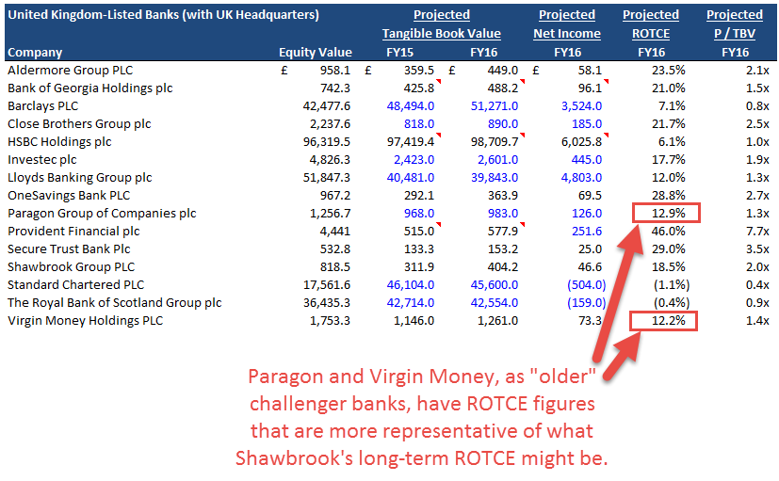

Valuation Impact: If you assume that ROTCE declines from 17% to 13% over five years and that the long-term ROTCE is 13%, the company’s implied per-share value in the DDM is £2.78, which is a 15% discount to its current share price. With our lower figures for ROTCE, this drops to £2.38, or a ~27% discount to its current share price.

- BTL Mortgage Risk Weightings Are Likely to Increase from 35% to 90%: While this change is not certain and may take effect only in FY19, the company will have to begin setting aside extra regulatory capital if it is announced anytime soon. UK regulators are currently considering whether or not to adopt this suggestion from the Basel Committee. If you assume that Risk-Weighted Assets as a percentage of Interest-Earning Assets increase from 62.5% to 80.0% rather than 70.0% over five years, the company’s implied value barely changes (~3% difference in the DDM with this assumption extended over 15 years).

However, the real impact of this change will likely be seen in factor #1 above: slower-than-expected mortgage (and other loan) growth.
To value Shawbrook, we created three scenarios in our model: the Base Case, the Upside Case, and the Downside Case. The primary differences are outlined below:
- LIBOR: Increases from 0.23% to 1.35% over five years in the Base Case, 1.55% in the Upside Case, and 1.05% in the Downside Case.

- UK Nominal GDP Growth Rate: 2.5% dropping to 2.0% by Year 5 in the Base Case; 3.0% to 3.5% in the Upside Case, and in the Downside Case, (3.0%) growth in each year of a 2-year recession followed by 1.0% and 2.0% growth in the recovery phase.

- Addressable Lending Market Share: This varies by segment, but in Commercial Mortgages the company’s share increases from 0.27% to 0.80% over five years in the Base Case, to 1.00% in the Upside Case, and to 0.70% in the Downside Case.

- Net Charge-Offs and Provisions: These make a small difference because they’re such low percentages; the Base Case numbers in Commercial Mortgages increase by around 50% over five years, while the Upside Case goes up by only ~20% and the Downside Case goes up by almost 100% before settling down at a figure ~50% higher than the original one.

- Long-Term ROTCE in the Dividend Discount Model: The Base Case progresses from 17-18% down to 12% over ten years; the Downside Case goes from 14-15% down to 11%, and the Upside Case goes from 20-21% down to 14%.

- Long-Term Asset Growth in the Dividend Discount Model: The Base Case progresses from 12-13% down to 7% over ten years; the Downside Case goes from 13-14% down to 6%, and the Upside Case goes from 14-15% down to 8%.
The company is much more likely to follow the Base or Downside Case rather than the Upside Case because GDP growth, LIBOR, and long-term ROTCE all seem too high in that scenario.
Our 15-year DDM shows the company as overvalued by ~50% in the Downside Case, ~30% in the Base Case, and undervalued by ~30% in the Upside Case. We believe there is a far greater chance of the company’s stock price declining by 30-50% than there is of it increasing by 30%.
Even if some of the factors above turn out to be incorrect, any one or two of them represents a significant difference from the current market view of the stock and could result in a substantial gain.
If everything above turns out to be false, there is a modest chance that Shawbrook could be undervalued and that its stock price could increase substantially – however, we could hedge against this risk by purchasing call options and longing other commercial banks.
Return to Top.
Catalysts
Catalysts in the next 6-12 months include:
- Risk weightings on BTL mortgages increasing from 35% to 90% (the announcement alone will trigger a change in banks’ policies).
- A slowdown in loan growth, which will trigger commercial mortgage growth of only ~3x over the next five years.
- A ~1% compression of loan interest spreads as more competitors enter the market, and a funding cost increase of 0.3% – 0.5%.
- The expiration of the lockup period on Pollen Street Capital's 45% stake.
Catalysts #1 and #2 are interrelated and, together, make the most significant valuation impact; catalyst #3 also makes a big impact because lower interest spreads on loans and higher funding costs, when carried through all 15 years of our dividend discount model, reduce the company’s intrinsic value by ~10%.
The fourth catalyst does not directly impact the company’s intrinsic value, but it could trigger a wider sell-off of the stock.
To determine the per-share impact from these catalysts, we rely upon our Base Case financial projections for Shawbrook, which reflect the impact of all these catalysts together, as well as Upside Case projections that are closer to research analysts’ estimates.
We also created Downside Case financial projections that show the impact of a 2-year recession with 3% GDP declines followed by a recovery.
We rely primarily on the Dividend Discount Model (DDM) to illustrate the impact of these catalysts. Many of these catalysts make a significant difference only in the long term, so the DDM is more appropriate than other methodologies.
Also, we will group together catalysts #1 and #2 in this discussion because they are interrelated and the change in BTL mortgage risk weightings will likely result in slower loan growth.
For reference, here is the output from the DDM under the “Base Case” assumptions but with GDP growth and Shawbrook’s commercial mortgage market share taken from the Upside Case (resulting in 4x growth over five years rather than 3x growth):
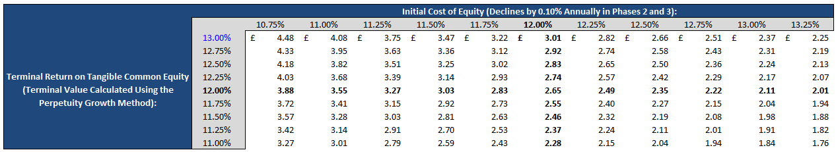
Long-term ROTCE is still 12%, but it declines from 18% initially rather than 16%. Under these conditions, there is a small chance that the company might be undervalued if you assume a lower Cost of Equity and higher long-term ROTCE.
With both those assumptions removed, however, the company’s intrinsic value declines by nearly £0.30 per share, representing a difference of almost 10% vs. its current share price:
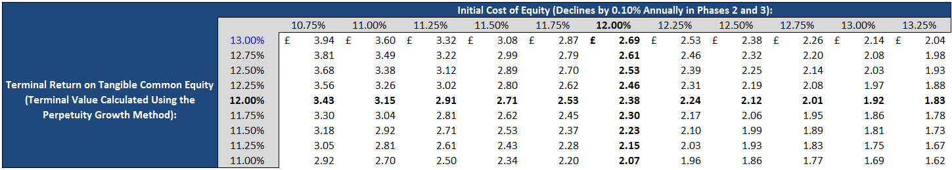
Under these new assumptions, which match our Base Case estimates exactly, it seems extremely unlikely for the company to be overvalued because only a few cells in the table have share prices greater than £3.27.
As another way to check this result, we can examine the company’s implied value in the Upside Case, but modify the GDP growth and commercial mortgage market share assumptions to match the lower figures from our Base Case instead.
Here is the sensitivity table from the DDM in the Upside Case before modifying anything:
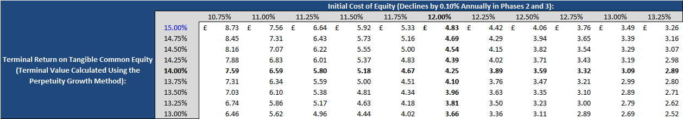
After modifying those two assumptions and leaving everything else alone, including the long-term ROTCE assumptions, the table changes significantly:
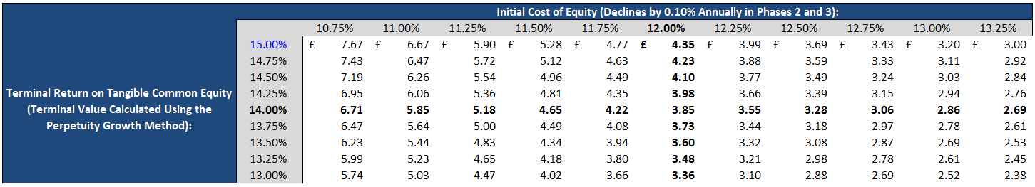
The company’s implied value in the center of the table declines by £0.40, a difference of more than 10% vs. its current share price.
This discussion has also ignored the lower market shares we’ve assumed for the company’s other loan segments: taken together, those result in an even greater valuation difference.
Key Takeaways: This one change reduces the company’s implied value by 10-15%, depending on the scenario and other assumptions.
We believe that lower GDP growth and the slowdown in commercial mortgages are extremely likely because:
- Numerous sources, including a faculty member at the Warwick Economics Research Institute, have made comments like the following:
“Expectations are for 2-3% nominal growth, falling to 2% over time. We think the Bank of England will keep interest rates low, despite statements to the contrary, due to fears of a slowdown in emerging markets.”
- The maximum nominal UK GDP growth rate in the post-financial-crisis years was 2.9%, and it is unclear how or why this could accelerate to 3.0% – 3.5%, as we assumed in the Upside Case:
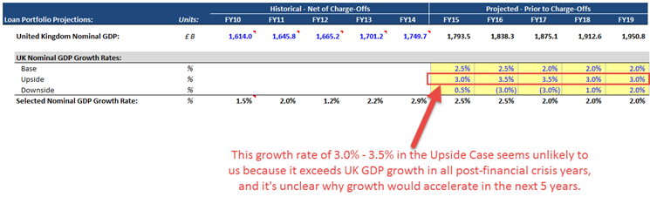
- Almost everyone we spoke with in the real estate market has reported lower-than-expected property sales and sluggish performance. One agent in South Kensington made the following comments:
“Sales of higher-end residences have been sluggish this year, and we’ve had to reduce prices in several cases to complete deals. Transactions are also taking about 20-30% longer to close than in past years. Foreign money is still flowing in, but the volume has decreased greatly.”
- Shawbrook has already reported lower-than-expected loan growth for 1H15, and the overall mortgage market in the UK has been slow to recover, comprising a smaller percentage of UK GDP each year:
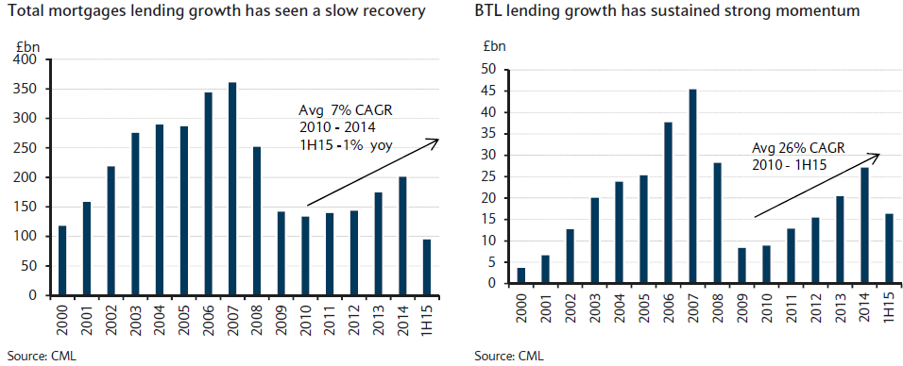
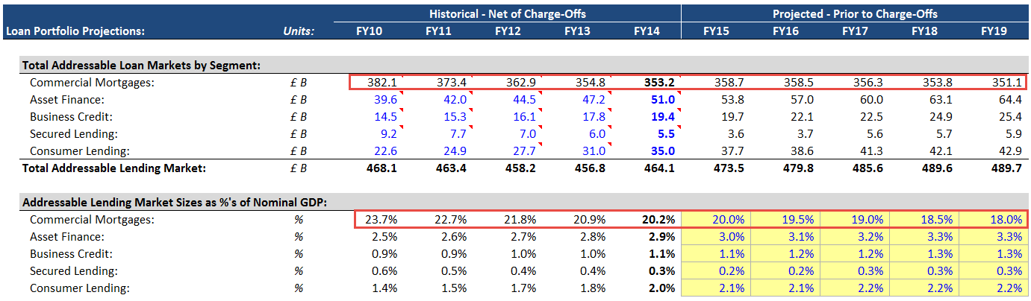
BTL lending has grown much faster than total mortgage lending, but a slowdown in that market is also imminent – the graph above shows that the 1H15 results are only around 50-60% of 2014 results, indicating that this year’s annual growth rate will be less than the 26% CAGR over the past several years.
- Recent legislation proposed by George Osborne, such as higher taxes and stamp duty increases, will result in reduced demand for BTL mortgages, even among “professional” landlords.

- Finally, we believe that increased competition will result in lower-than-expected market share gains for the company. One real estate broker even made the following comments:
“Shawbrook won the vast majority of competitive deals 2-3 years ago, but we’ve seen their win rate come down as more firms have entered the market. I could see them continuing to increase their share within the BTL and broader mortgage markets, but I don’t think it will go above 1% anytime soon, especially given the continued presence of the high street banks and more challengers popping up.”
Shawbrook’s Gross Asset Yield of 6.3% on its commercial mortgages also exceeds those of its competitors (Aldermore is at 5.1% for residential and 6.0% for SME, and OneSavings is at 5.8%).
The third catalyst, a ~1% compression of loan interest spreads and a funding cost increase of 0.3% – 0.5%, also makes a significant difference because the company’s Return on Tangible Common Equity will decline as a result.
For reference, the company had the following loan interest spreads and funding costs in its last fiscal year:
- Commercial Mortgages: L + 600 bps
- Asset Finance: L + 970 bps
- Business Credit: L + 670 bps
- Secured Lending: L + 980 bps
- Consumer Lending: L + 1140 bps
- Average Interest Rate on Deposits: 2.6% (declining to 2.4% in the first projected year)
- Average Interest Rate on All Interest-Bearing Liabilities: 2.7%
If you hold these assumptions constant and then also adjust the company’s long-term ROTCE in the dividend discount model, the output is as follows:
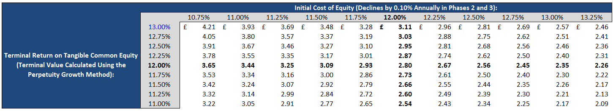
Our Base Case scenario makes the following interest rate assumptions instead:
- Commercial Mortgages: L + 600 bps Declines to L + 470 bps by Year 5
- Asset Finance: L + 970 bps Declines to L + 890 bps by Year 5
- Business Credit: L + 670 bps Declines to L + 600 bps by Year 5
- Secured Lending: L + 980 bps Declines to L + 900 bps by Year 5
- Consumer Lending: L + 1140 bps Declines to L + 1000 bps by Year 5
- Average Interest Rate on Deposits: 2.6% Declines initially but then rises to 2.7% by Year 5
- Average Interest Rate on All Interest-Bearing Liabilities: 2.7% Declines initially but then rises to 3.0% by Year 5
With those assumptions, the company’s implied share price falls by £0.30 to £0.40 across much of the table, representing a differential of 10-15% vs. Shawbrook’s current share price:
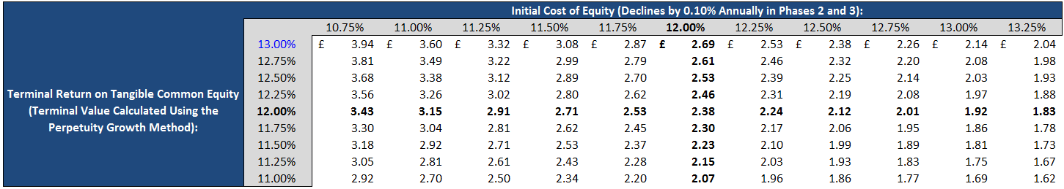
Most research analysts predict that gross asset yields will stay about the same and that liability yields will decrease or stay the same:
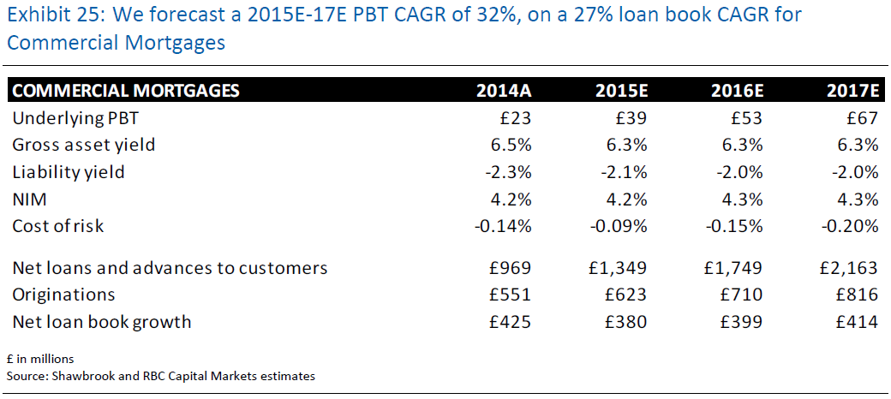
However, we believe that asset yields will decrease while the rates paid on liabilities will increase for the following reasons:
- Shawbrook is already charging rates higher than most of its specialty lender competitors on its commercial mortgages:
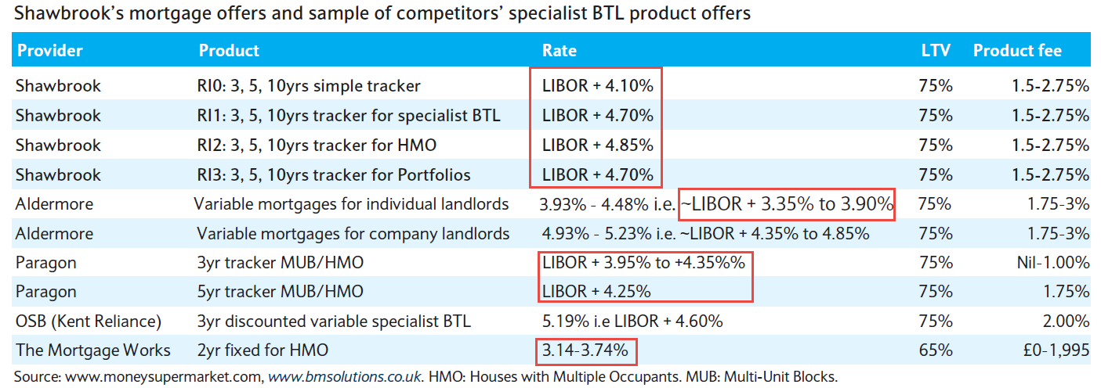
- However, there is no clear reason landlords will continue to accept these rates; one landlord who owns five properties in London made the following comments regarding mortgage pricing and lender selection:
“I have so many more options than I did even 2-3 years ago that I’m still undecided. I get better service from the smaller banks, but within that group, there’s quite a bit of variance in pricing, with some banks charging 1-2% more than others on similar mortgages.”
Given that the fees, LTV ratios, and other terms are similar, we believe there is a strong likelihood that the company’s yields will decline in the future.
Additionally, the company’s Gross Asset Yield has already declined by 2.0% over the past 3.5 years when there was less competition in the market:
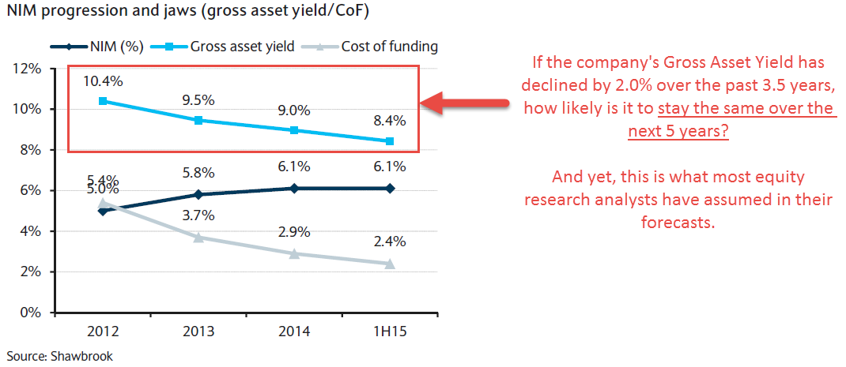
On the cost of funding side, the company has seen a substantial decline over the past 3.5 years, resulting in its Net Interest Margin (NIM) increasing (see the diagram above).
However, we are skeptical that this trend will continue for two key reasons:
- Fifty percent of Shawbrook’s funding consists of deposits with terms of less than one year. Analysts publish charts like the one below, but they ignore how ~75% fixed-rate deposits won’t help much if half the company’s funding is short-term and interest rates are set to rise over the next several years:
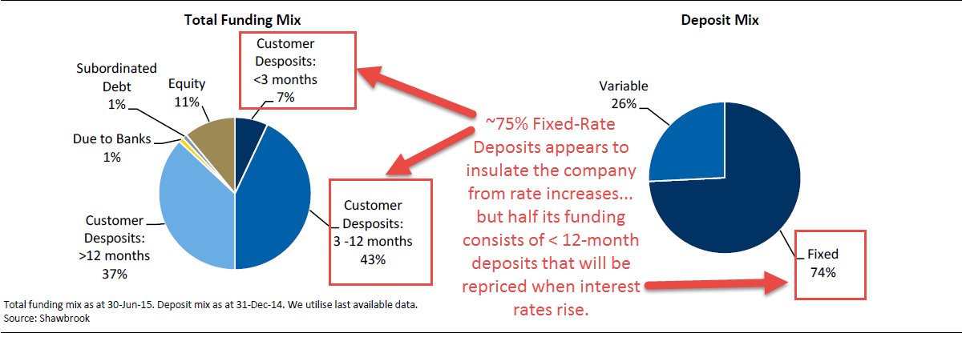
- Interest rates will almost certainly rise by a modest amount over the next five years. While the Bank of England has kept rates at 0.5% for seven years in a row, rates cannot remain that low forever. Even if they do not return to “normal” levels anytime soon, an increase to at least 1.0% over the next five years seems plausible. Forward market interest rates imply the following patterns:
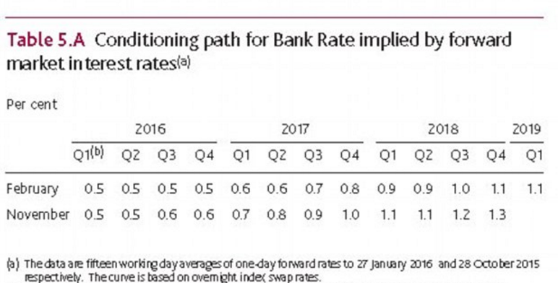
Additionally, Howard Archer, chief economist at IHS Global Insight, recently made the following comments on interest rates:
“We expect the Bank of England to only lift interest rates to 1.25 per cent by end-2017 and 2.25 per cent by end-2018.”
Another anonymous source close to the Bank of England made the following comments:
“You’re unlikely to see interest rates above 1.0% for the next few years, and any rate increases will be gradual and will rise to a lower level than in past periods.”
So while there is disagreement over the timing and magnitude of rate increases, everyone agrees that there will be at least some increase in the next five years.
This change will negatively impact Shawbrook because its loan interest spreads are expected to decline, meaning that its Gross Asset Yields will stay about the same or fall slightly while its funding costs rise slightly.
All these factors represent catalysts that could reduce Shawbrook’s share price to our targeted range of £1.73 – £2.38 (a 27% – 47% decline) in the next 12 months.
If everything above comes true and the UK economy goes into a recession, the price may be near the lower end of that range; if one or more of the conditions above is false and economic growth remains lower but stable, a price near the upper end of that range is more plausible.
If we’re wrong about everything and UK economic growth and mortgage market growth surpass expectations, the company’s share price might increase by 30%, which we could hedge against via the methods describe in the Risk Factors section.
Return to Top.
Valuation
We have valued Shawbrook using public comps, precedent transactions, and the Dividend Discount Model. We also ran a Residual Income (Excess Returns) Model as a supplement to the DDM and looked at the implied P / TBV multiples from a regression analysis.
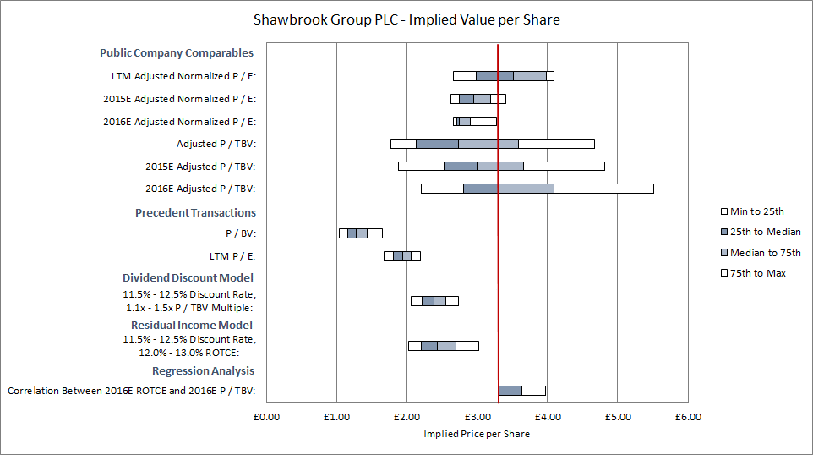
Here is the company’s implied share price using our “Base Case” estimates (Shawbrook’s current share price is in red):
NOTE: We have adjusted the comparable public companies for excess or deficit capital under the assumption that all companies in the set are targeting a 13% CET 1 Ratio, as Shawbrook is.
As shown above, the company’s current share price is well above the implied range from the DDM and Residual Income Models and the precedent transactions, and even above the share prices implied by the median P / E multiples from the public comps.
On a P / TBV basis via both the public comps and the regression analysis, it appears to be valued appropriately, if not slightly undervalued.
We will discuss each methodology in more detail below and show several sensitivities based on the key value drivers and catalysts.
Comparable Public Companies
To select comparable public companies, we used the following criteria:
- Industry: “Challenger Banks” (i.e., Relatively young specialty lenders founded within the past ~20 years, and ideally the past 5-10 years)
- Financial: Total Assets between £1 billion and £50 billion
- Geography: UK-listed and UK-based companies
This set of criteria yielded four comparable banks: Virgin Money (VM.), Aldermore Group (ALD), OneSavings Bank (OSB), and Secure Trust Bank (STB).
We calculated the Excess or Deficit Capital for each comparable bank as of the valuation date and adjusted their Tangible Book Value and Net Income to Common figures based on this figure and an assumed risk-free rate of return of 1.94% (the 10-year UK government bond rate).
We also adjusted Net Income for non-recurring charges (primarily IPO listing fees).

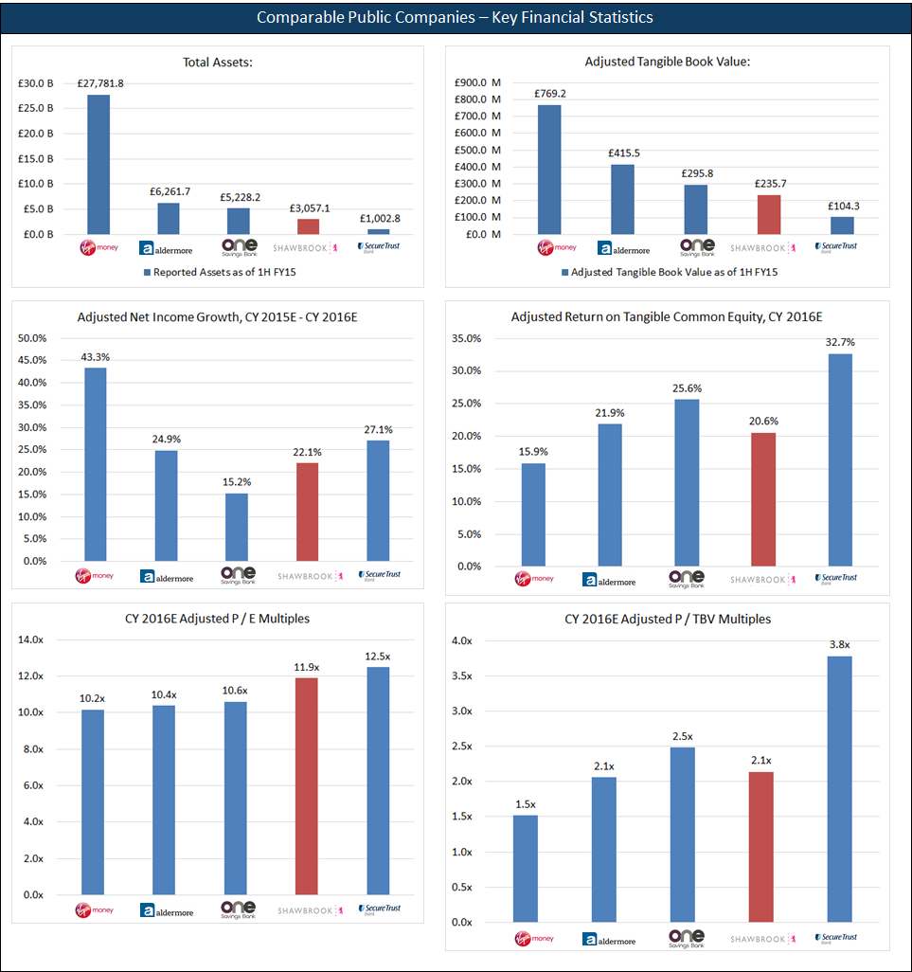
Key Takeaways: The comparable companies are not terribly useful because they show that Shawbrook is reasonably valued based on P / TBV multiples since its ROTCE and P / TBV are both in the middle of the range. On a P / E multiple basis, it may be overvalued since it has the second-lowest Adjusted Net Income Growth Rate, but the second-highest multiple.
Note that the figures for comparables are based on research estimates and that our view of the company’s future performance barely even makes an impact over the next two years.
Also, note that we have adjusted the comparable public companies for non-recurring charges and Excess or Deficit Capital based on a targeted 13% CET 1 Ratio.
For reference, here’s the set of comparables with all the metrics and multiples:
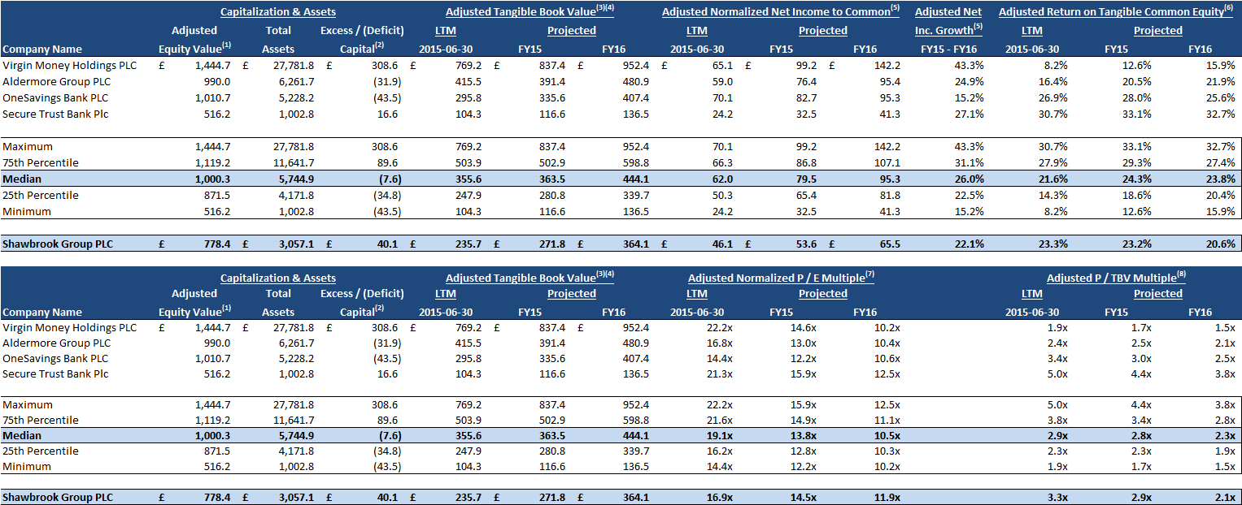
Return to Top.
Precedent Transactions
We used the following screening criteria for the seller in each M&A deal:
- Industry: Commercial Banking
- Financial: Total Assets between £1 billion and £50 billion
- Geography: Must be UK-listed and UK-based companies
- Time Horizon: September 18th, 2011 to September 18th, 2015
- Other: We considered sales of entire companies as well as majority stakes, but ignored minority stake deals; we added 50% of earn-outs to the equity purchase prices
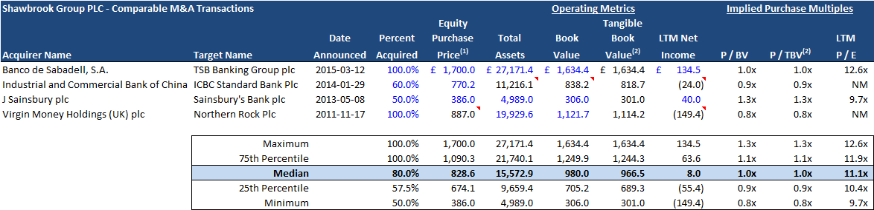
These criteria produced the following set of precedent transactions:
Key Takeaways: The M&A transactions here are the least meaningful methodology because there are so few of them, and only one (Banco de Sabadell / TSB) is comparable to Shawbrook in any way.
We examined these transactions in the interest of completeness, but they are not particularly useful or accurate next to the other methodologies.
Return to Top.
Dividend Discount Model
We used the Dividend Discount Model over a 15-year period as our primary valuation methodology, with the following assumptions:
- Phases: The analysis is split into three phases, with Phase 1 corresponding to the five years in our 3-statement projection model (initial dividend issuances), Phase 2 corresponding to slowing dividend growth in the five years after that, and Phase 3 corresponding to a stabilized dividend payout ratio in the five years after that.

- Cost of Equity: This is initially 12%, but it declines to 11% over Years 6 – 15 of the analysis to reflect the reduced risk and reduced potential returns as Shawbrook grows.

- Targeted Dividend Payout Ratio: This increases from 10% in FY16 to 40% in FY19, and then grows to 50% by FY24 and remains there. Note that the company’s actual payout ratio stays well below this figure, at approximately 38%, in the Base Case.
- Targeted CET 1 Ratio: 13%, in-line with the company’s current goals. We handle Excess or Deficit Capital via additional or reduced dividend issuances.

- ROTCE and Long-Term / Final ROTCE: In the final ten years, this varies across the cases:
  - Base Case: Initially 16%; declines to 12% by the final three years.
  - Upside Case: Initially 18%; declines to 14% by the final three years.
  - Downside Case: Initially 14%; declines to 11% by the final three years.

- Asset Growth and Long-Term / Final Asset Growth: This also varies in the same period:
  - Base Case: Initially 11%; declines to 7% by the final three years.
  - Upside Case: Initially 14%; declines to 8% by the final three years.
  - Downside Case: Initially 12.5%; declines to 6% by the final three years.

- Other Assumptions: RWA as a % of Total Assets is ~70% at the end of our 5-year projections and rises to 80% over the next five years; Goodwill & Other Intangibles as a % of Total Assets declines from 1.10% to 1.00% and stays there.
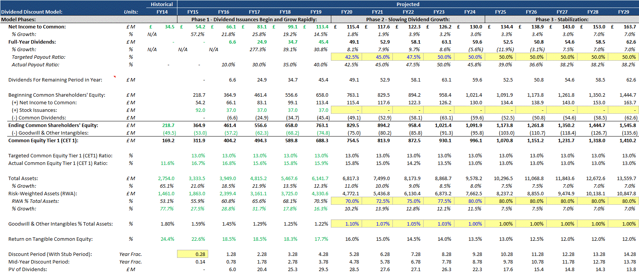
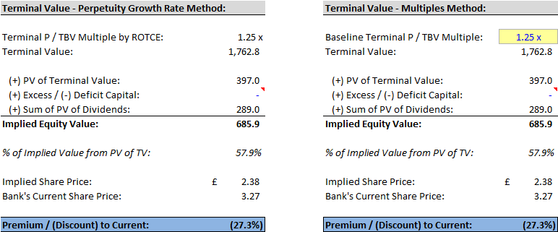
For reference, here is the baseline output of the DDM analysis under both the Multiples Method and the Perpetuity Growth Method for the Terminal Value calculation:

We have also assumed that future stock issuances contribute approximately 38 million in additional shares, based on the company’s current stock price, the GBP value of future stock issuances, and their present value.
The Asset Growth assumption makes a marginal difference in this analysis, especially when it is limited to the last three years of the model and the Terminal Period, but the sensitivities based on Cost of Equity and Terminal Value are significant:
Sensitivity – Initial Cost of Equity vs. Terminal P / TBV Multiple:
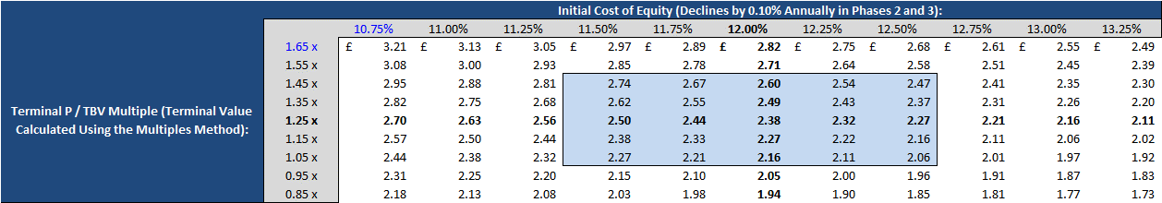
Key Takeaways: It seems virtually impossible that the company could be undervalued because the maximum implied share price shown in this table is £3.21, which is below its current share price of £3.27. Instead, the company seems overvalued by 16% – 37% in the blue range above.
Sensitivity – Initial Cost of Equity vs. Terminal Return on Tangible Common Equity:
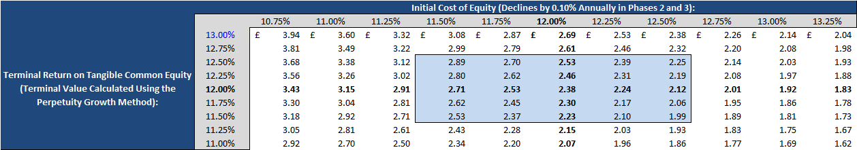
Key Takeaways: The company’s valuation is a bit higher in some cases and lower in others, but it still seems very unlikely to be undervalued – for this to happen, Shawbrook’s long-term ROTCE would have to exceed the current ROTCE figures for Virgin Money and Paragon, the more mature specialty lenders.
Return to Top.
Residual Income (Excess Returns) Model
As an alternative to the Dividend Discount Model, we also built a Residual Income Model (AKA Excess Returns Model) where a bank’s intrinsic value is equal to:
- Current Common Book Value + Sum of PV of Residual Income + PV of Residual Income Terminal Value
“Residual Income” is defined as ROE * Average Equity – Cost of Equity * Average Equity, or in this case, ROCE * Average Common Equity – Cost of Equity * Average Common Equity.
This model can work better for banks that are not currently issuing dividends or that have irregular payout ratios, since much of the bank’s value comes from its current Balance Sheet, with the rest determined by ROE vs. Cost of Equity. Far less of the bank’s implied value comes from its Terminal Value.
To implement this model for Shawbrook, we used similar assumptions and almost the same setup as in the Dividend Discount Model, but we used slightly higher figures for the long-term ROCE since Return on Common Equity is numerically higher than Return on Tangible Common Equity.
We handled Excess or Deficit Capital differently because valuation is not based on dividends in this model; instead, we adjusted ROCE * Average Common Equity and Cost of Equity * Average Common Equity according to the bank’s capital levels and the assumed 1.94% rate of return on excess capital.
Despite these model differences, the results were quite similar in the Base Case:
Sensitivity – Cost of Equity vs. Terminal Return on Common Equity:
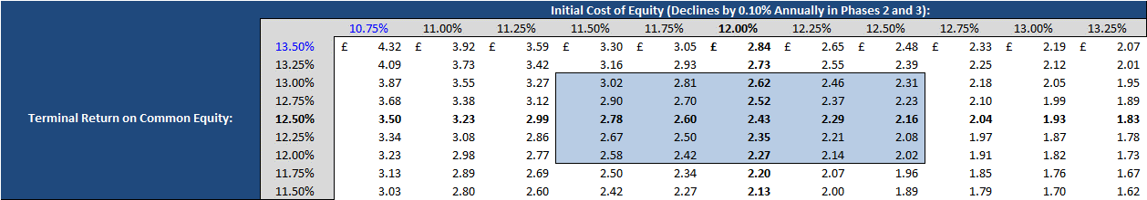
Key Takeaways: The implied values are slightly higher than in the DDM, but once again, the company’s long-term ROCE would have to exceed those of the more mature comparable banks and its Cost of Equity would have to be a good amount lower for it to be undervalued.
The sensitivity on the Final Year Total Asset Growth Rate once again made a marginal difference, so we are not showing it here.
Return to Top.
Regression Analysis
As another way to check our valuation, we also built a regression analysis to determine the relationship between FY16 ROTCE and P / TBV for a broad set of UK-based commercial banks.
This set included 15 UK-based banks, ranging from “The Big Five” (Barclays, HSBC, Lloyds, Standard Chartered, and RBS) down to specialty lenders such as Shawbrook and its peer group.
We then used this relationship to calculate Shawbrook’s implied FY16 P / TBV multiple and Implied Equity Value.
We did not adjust any of these figures for Excess or Deficit Capital because the banks were very different sizes and focused on different markets. The output is below:
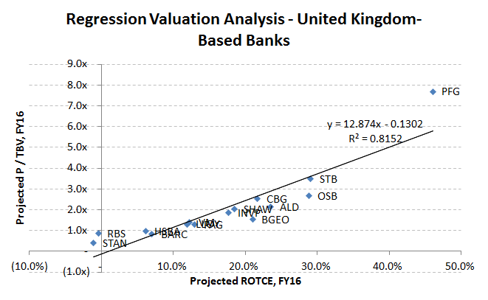
In the Base Case, the Regression Analysis produced an implied share price of £3.63 for Shawbrook; the Upside Case was £4.23, and the Downside Case was £2.87.
These results are not terribly surprising: similar to the multiples from the public comps, Shawbrook seems valued appropriately and perhaps slightly undervalued if you consider only its financial performance in the next 1-2 years.
Valuation Conclusions
The most meaningful methodologies are the Dividend Discount Model and Residual Income Model, and the conclusions depend strongly on your view of Shawbrook.
In the Base Case, the company appears overvalued by ~30%; in the Upside Case, it appears undervalued by ~30%, and in the Downside Case it appears overvalued by ~50%.
We lean toward the Base and Downside Cases being the most likely outcomes, in which case the company may be overvalued by 30-50%.
Return to Top.
Investment Risks
The top risk factors include:
- Risk weightings on BTL mortgages not changing or changing by less than expected;
- The commercial mortgage market growing more quickly than expected, or Shawbrook capturing a higher-than-expected market share; and
- Loan interest spreads remaining the same or increasing, and funding costs decreasing or staying about the same.
We’ll address each of these risk factors and explain how to mitigate them below:
Risk Weightings on BTL Mortgages Not Changing or Changing by Less Than Expected
As mentioned in the section on Catalysts, the risk weightings on BTL mortgages – as expressed in the model via different assumptions for Risk-Weighted Assets as a percentage of Interest-Earning Assets or Total Assets – make a small difference in the output.
For example, if you assume that the company’s RWA as a % of IEA is 80% rather than 70% at the end of five years, and then you extend that across the next ten years of the DDM, its implied value changes by only 3%. A 10% differential is reasonable given that BTL mortgages represent 23% of Shawbrook’s loan portfolio.
So by itself, this specific risk factor barely makes a difference on the company’s implied value.
The real impact is that these higher risk weightings will cause the company’s loans to grow more slowly than expected (see the next section).
The Commercial Mortgage Market Growing More Quickly Than Expected, or Shawbrook Capturing a Higher-Than-Expected Market Share
We addressed both of these risk factors in the section on Catalysts: if Shawbrook’s commercial mortgage loan portfolio grows by 3x rather than 4x over five years, it changes the company’s implied value by approximately 10-15%.
More broadly, higher UK GDP growth and market share gains for Shawbrook across all loan segments translate into significantly higher numbers in our Upside Case, where the company is undervalued by ~30%.
While it’s possible for the broader lending markets and BTL mortgages to grow at faster-than-expected rates, we are skeptical based on recent industry data:
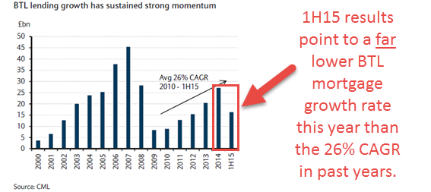
Not only were industry-wide numbers for 1H15 lower than expected, but Shawbrook’s results for the first half of the year came in lower than expected. Virtually everyone we spoke with reported a slow market, with comments like the following:
“Sales of higher-end residences have been sluggish this year, and we’ve had to reduce prices in several cases to complete deals. Transactions are also taking about 20-30% longer to close than in past years. Foreign money is still flowing in, but the volume has decreased greatly.”
So we are reasonably confident that commercial mortgage loan growth and BTL loan growth specifically will be lower than expected.
If we are wrong, we could hedge against this risk in several ways:
- Purchase call options with strike prices about 20% higher than Shawbrook’s current share price (£3.93 vs. £3.27). We see no reason to accept more than a 20% loss if the potential gains are in the 30-50% range.
- Long a more BTL-focused competitor. For example, 91% of Paragon’s loan book consists of BTL mortgages, and OneSavings Bank’s exposure is 55%. That way, if we’re completely wrong about the slowdown in BTL mortgages, we could take advantage of the upside elsewhere.
- Long a more diversified, larger bank. For example, we could long one of the Big 5 banks with significant mortgage exposure, or even long an index fund or ETF that tracks the entire commercial banking or real estate sectors in the UK.
Loan Interest Spreads Remaining the Same or Increasing, and Funding Costs Decreasing or Staying About the Same
In all the scenarios in our model, we assumed a modest decline of ~1% in LIBOR spreads on the company’s assets over the next five years:
- Commercial Mortgages: L + 600 bps Declines to L + 470 bps by Year 5
- Asset Finance: L + 970 bps Declines to L + 890 bps by Year 5
- Business Credit: L + 670 bps Declines to L + 600 bps by Year 5
- Secured Lending: L + 980 bps Declines to L + 900 bps by Year 5
- Consumer Lending: L + 1140 bps Declines to L + 1000 bps by Year 5
- Average Interest Rate on Deposits: 2.6% Declines initially but then rises to 2.7%
- Average Interest Rate on All Interest-Bearing Liabilities: 2.7% Declines initially but then rises to 3.0% by Year 5
With these assumptions factored in, the company’s implied share price falls by £0.30 to £0.40, representing a differential of 10-15%.
Most research analysts, by contrast, have predicted that spreads will stay about the same.
For reasons mentioned in the section on Catalysts, we are reasonably confident that spreads will decline: Shawbrook charges more than its competitors, more and more lenders are entering the market, and customers seem to be price-sensitive.
On the funding cost side, we believe that LIBOR and overall rates will rise modestly over the next five years, which will increase Shawbrook’s cost of funding. Yes, 75% of its deposits are fixed-rate, but only 50% have terms of greater than one year.
If we’re wrong, we could hedge against this risk in several ways:
- Purchase call options with strike prices about 15% higher than Shawbrook’s current share price (£3.77 vs. £3.27).
- Set a buy-stop order on Shawbrook’s shares in the same price range. If asset yields stay the same or move in the other direction, we could limit our losses to 15% if we begin buying shares at this level.
- Long a competitor that stands to benefit from decreased funding costs. For example, Aldermore and OneSavings Bank both have Net Interest Margins that are between 3.0% and 4.0%, significantly lower than Shawbrook’s at ~6.0%. If funding costs decrease, these competitors could benefit substantially.
The Worst-Case Scenario
Another risk is that we could be wrong about everything above: perhaps mortgages will grow as fast or faster than expected, the BTL mortgage risk weightings will not change, the loan interest spreads will stay the same, and the funding costs will decrease or stay the same.
To examine this possibility, we used the Upside Case but kept all the LIBOR spreads on loans the same for five years and set the interest rate on fixed-rate deposits to 2.4%.
The result was a significantly higher ROTCE in the five projected years, which ranged from 23% to 25%; if we reflect this much higher ROTCE in the DDM, but still make it decline to 14% by the end of the 15-year period, we get the following results:
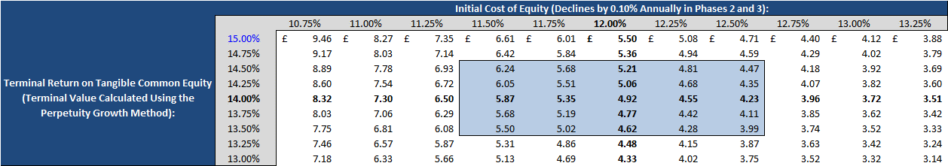
Therefore, if everything in our recommendation goes wrong, the company might be undervalued by 50%+.
We believe this outcome is extremely unlikely because channel checks and industry research point to declining yields and lower-than-expected loan growth.
Since this is a short recommendation, our potential losses are unlimited. The only ways to hedge against this worst-case scenario include:
- Purchase Call Options or a Buy-Stop Order: Given the 30-50% in potential gains, we would not accept more than a 20% loss and we would set the strike price of these options or the price of the buy-stop order in that range.
- Long the Sector or Specific Competitor Banks: Depending on the risk factor we believe is most credible, we might long either the entire sector (e.g., if we’re completely wrong on the GDP growth or commercial mortgage estimates) or specific banks that would benefit the most from asset yields or funding costs moving in the opposite direction of what we expect.
We would need to conduct additional research to highlight the best candidate(s) for hedging purposes, but we might start the process with those ideas.
Return to Top.

